NEW BRUNSWICK ALMUNI KAPPA LEAGUE
2020-2021 MEMBERSHIP APPLICATION

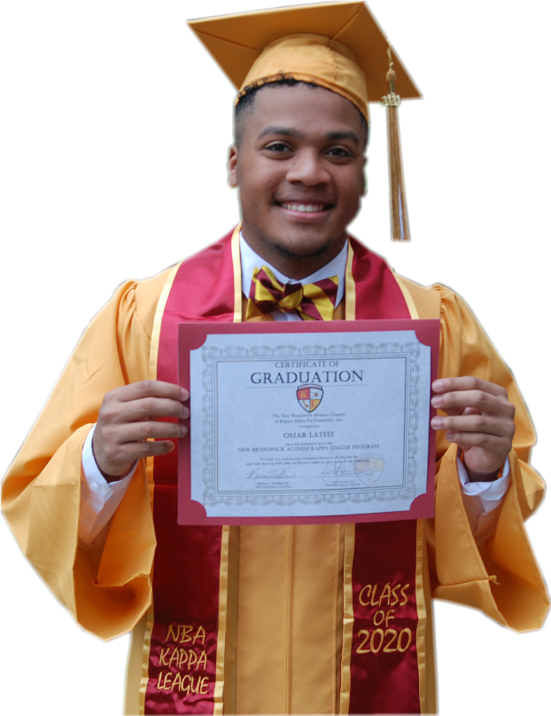

ACHIEVEMENT HAPPENS HERE

THE PROGRAM
The New Brunswick Alumni Kappa League (NBAKL) program is a mentoring program formed under the Guide Right Program of Kappa Alpha Psi Fraternity, Inc. NBAKL was formed in 2003. Our goals are:
1. To help youth in selection of courses leading to vocations compatible with their aptitudes and personalities.
2. To assist students while they are in training, to get started in employment, and to progress successfully in their chosen fields.
3. To assist parents in the handling of their children by giving them opportunities to talk over their problems with those who know and are successful in their chosen vocations.
4. To afford the less fortunate youths a respite from the drudgery of the streets, through sponsored entertainment and cultural enrichment.
5. To inform youth of the values of higher education, of assistance available for continued educational pursuits, scholarships, loans, professional counseling, fellowships, etc., of various occupational and professional opportunities.
Since its inception, over 125 students have graduated from the program and matriculated to colleges/universities such as Rutgers University, Morehouse College, United States Naval Academy, United States Air Force Academy, Rowan University, Hampton University, Georgia State University, New Jersey Institute of Technology, Howard University, Texas A&M and many others notable institutions. We have also had graduates join the United States Navy and the United States Army. Our overall goal is to help each young man develop their talents and pursue and attain their career goals. It is not purely to have each student go to college, particularly if that is not their goal.
MEMBERSHIP REQUIREMENTS
The New Brunswick Alumni Chapter of Kappa Alpha Psi Fraternity, Inc. is pleased that you have decided to apply for membership into the NBA Kappa League. The program requires all applicants to submit a complete membership package.
Membership Qualifications
- Must be willing to attend monthly meetings, community service activities and workshops
- Must be a male student between 7th – 12th grade
- Must have a cumulative GPA of 2.75 (78%) or better
- Must complete an interview with the committee

HOW TO APPLY:
- Complete the application.
- Provide a copy of your (final) 2019‐20 report card or high school transcript
- Provide a copy of current class schedule for upcoming academic semester.
- Remit application fee: $50.00.
Checks made payable to New Brunswick Alumni Chapter of KAΨ.
- Attach a recent picture of yourself.
- Application must be post-marked by 08/23/2020.
- Candidate interviews are tentatively scheduled for September 12, 2020. This could be affected by coronavirus protocols. More information will be distributed.
- Mail complete package to:

Dr. Larnie Booker
NBA Kappa League
93 S. Dover Avenue
Somerset, NJ 08873

Follow us on Social Media
Instagram: @nba_kl
Twitter: @NBA_KL
YouTube: NBA Kappa League TV (subscribe to our channel)
Facebook: NBA Kappa League (currently Active Page)

 |  |  | New Member |  |  | Returning Member

Applicant Information
Applicant's Last Name |  |  | Applicant's First Name, MI
Date of Birth | Age |  | Home Phone
Home Address |  |  | Cell Phone
City, State, Zip Code |  |  | Email Address
Current School |  |  | Grade

We ask that each Kappa League member or prospective member have their own e-mail address, not simply use their parent’s e-mail address. This is important for certain programs. A parent’s information will always be linked to a Kappa Leaguer.
Applicant Acknowledgement
I wish to participate in the NBA Kappa League. I understand that if I’m selected for membership, I am expected to attend meetings, participate in activities and complete required assignments. I also agree to adhere to the rules established by the NBA Kappa League program.
.

Applicant Signature: _______________________________________

Date: _______________________________

Parent/Guardian Information (#1)
Guardian's Last Name (1) |  |  | Guardian's First Name (1)
Relationship (Mother, Father, etc.) |  |  | Home Phone
Home Address |  |  | Cell Phone
City, State Zip Code |  |  | Email Address
Occupation/Job Title |  |  | Company
If address and home phone are the same as the applicant. You may enter SAME.

Parent/Guardian Information (#2)
Guardian's Last Name (2) |  |  | Guardian's First Name (2)
Relationship (Mother, Father, etc.) |  |  | Home Phone
Home Address |  |  | Cell Phone
City, State Zip Code |  |  | Email Address
Occupation/Job Title |  |  | Company
If address and home phone are the same as the applicant. You may enter SAME.

Please list your hobbies, interests, community service, sports, musical, art and/or extracurricular activities.
Activites (check all that apply)
Arts |  |  | Singing |  | Dance |  | Acting |  | Oratory |  | Musical Instrument
 |  |  |  |  |  |  |  |  |  |  | Which Instrument:
Sports |  |  | Basketball |  | Fencing |  | Golf |  | Swimming |  | Tennis |  | Other
 |  |  | Baseball |  | Football |  | Lacrosse |  | Track |  | Wrestling
Service
Hobbies

Aspirations
What are your future career aspirations?

List colleges/universities you are presently interested in attending.
1.
2.
3.
4.
5.
6.
7.
8.
9.
10.

Letter of Interest (New members only)
Provide a one-page, typed essay, incorporating the points below. You may also include any information about yourself that you deem to be important or special.

- Why are you interested in Kappa League
- What do you hope to gain from being a part of NBA Kappa League?
- What qualities or attributes would you bring to NBA Kappa League?

Medical/Educational Information
Please indicate if your child has any significant medical problems or food allergies.

Please indicate if your child has any educational or learning disabilities. Please include any specific areas of difficulty if possible. (The information that is shared will remain confidential and will be used solely to assist KL Advisors in providing support to you and your son.)

Parental Acknowledgment
I hereby give permission for my child to participate in the NBA Kappa League. I understand that NBA Alumni Chapter of Kappa Alpha Psi Fraternity, Inc., is not responsible for personal injury or loss of property. I understand that my child is free to leave the program at any time. I agree to immediately update this application when any information changes.

Parent/Guardian Signature: Date:

Parent/Guardian Signature: Date:

Release for Medical Treatment
In the event of an emergency and the inability of the NBA Kappa League Advisors to obtain my consent, I hereby give permission for NBA Alumni Chapter of Kappa Alpha Psi Fraternity, Inc., to authorize any medical treatment or surgery in which a qualified physician or surgeon shall deem prudent for my child.

Parent/Guardian Signature: Date:

Parent/Guardian Signature: Date:

In case of an emergency, which hospital or urgent care do you prefer to have your child transported?

Hospital/Urgent Care Facility:

Primary Care Physician's Name:

Primary Care Physician’s Phone Number:

Parent/Guardian Signature: Date:

Photo Release
I give permission to NBA Alumni Chapter of Kappa Alpha Psi Fraternity, Inc., to use or release any photos of my child taken for the purpose of promoting the NBA Kappa League program.

Parent/Guardian Signature: Date:

Parent/Guardian Signature: Date:

For Internal Use Only

